Next Steps:

The next steps for these models depend principally on how they are incorporated into the OA and/or Modeling Modules, and also on the results of ongoing research on the response of Thaps to changing environmental conditions.

There are some model specific changes which could be implemented now.

Specifically, in the Nutrient & Light Effect on Thaps model, the following changes need to be made. These are in order from highest to lowest priority:

* There is no effect of changing CO2 levels on growth of diatoms in the model. The second line of the “Go” function is a line which is commented out, but which would change the global variable growthRate. This variable determines how many diatoms are hatched in the function “reproduce”. Note that to implement this change it would be valuable to have lab data on the effect of CO2 on Thaps population size over time.
* The mixing button currently does nothing. It could be used to cause the nutrients to randomly shift patches. I do not think this would drastically modify the outcome of the model, so I didn’t invest the time.
* A binary system is in effect for whether the diatoms can pick up nutrients. See the “feed” function in the code. A random number between 0 and 19 is generated. If nutrients levels are high, 10 is subtracted from this number. If nutrients levels are low, the number is not changed. Then the numbers if compared to 5, and if it is greater, the diatom “picks up” the nutrient. This system seems artificial to me.
* The motion of the diatoms is not very appealing to the eye. They could be made to “diffuse” in more of a random walk within the bottom of the world.

In the cAMP model, the following changes could be made:

* Currently the number of CO2 turtles in the ocean does not dynamically change when the "CO2-amount" slider is moved during "Go". This can be deceptive since the graph and the gene pathway nodes do change. Perhaps the slider should only work before "Go" is pressed?
* Or, the whole model could be more dynamic during the "Go" phase. The slider might be disabled, and the CO2 node (turtle 5) would scale with the amount of CO2 in the ocean, so that the genetic pathway and the size of the CCM transporters would vary dynamically. I would think there should also be a feedback mechanism related to the amount of CO2 in the pyrenoid, such that the size of the CCM transporters decreases as the pyrenoid reaches saturation.

As additional research becomes available, the models could be tweaked in the following manners:

Nutrient & Light Effect on Thaps :

The upper panel in the world insinuates that there are effects of transcription factors on genes which affect cellular function. However, the actual connections don’t mean anything. For example, if we look at the picture below, it implies that HSF controls the expression of NRT3, NRT1, and SIT1, and that these three genes control the transport of Nitrogen. We do not know whether HSF actually regulate these three genes. NRT3 and NRT1 are in fact nitrate transporters, but SIT1 is a silicon transporter. Not only is the coding of specific connections tedious, but we don’t actually not what controls what at this point.

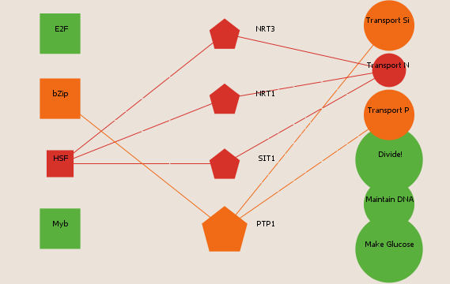

cAMP model:

There is a lot of room for improvement in this model as the research related to the transport mechanism of carbon in the diatom becomes clearer. Justin gave me a paper by Hopkinson: “A chloroplast pump model for the CO2 concentration mechanism in the diatom…”. The paper lays out a clearly fleshed out full model for the CCM which includes bicarbonate transfer and carbonic anhydrases. I judge it to be somewhat overkill for the scope of this model, as we just want to show the feedback of the amount of CO2 on the amount of pumping going on, but my judgement may be flawed or not relevant in the future.

Similarly, the genetic pathway pictured is currently sort of a “best guess” for what is going on. Justin told me that we are not sure the CYCc is involved. Hence as the pathway becomes clearer, a lot of revision might be required.